Group Names:

Evaluating Websites Summary Page
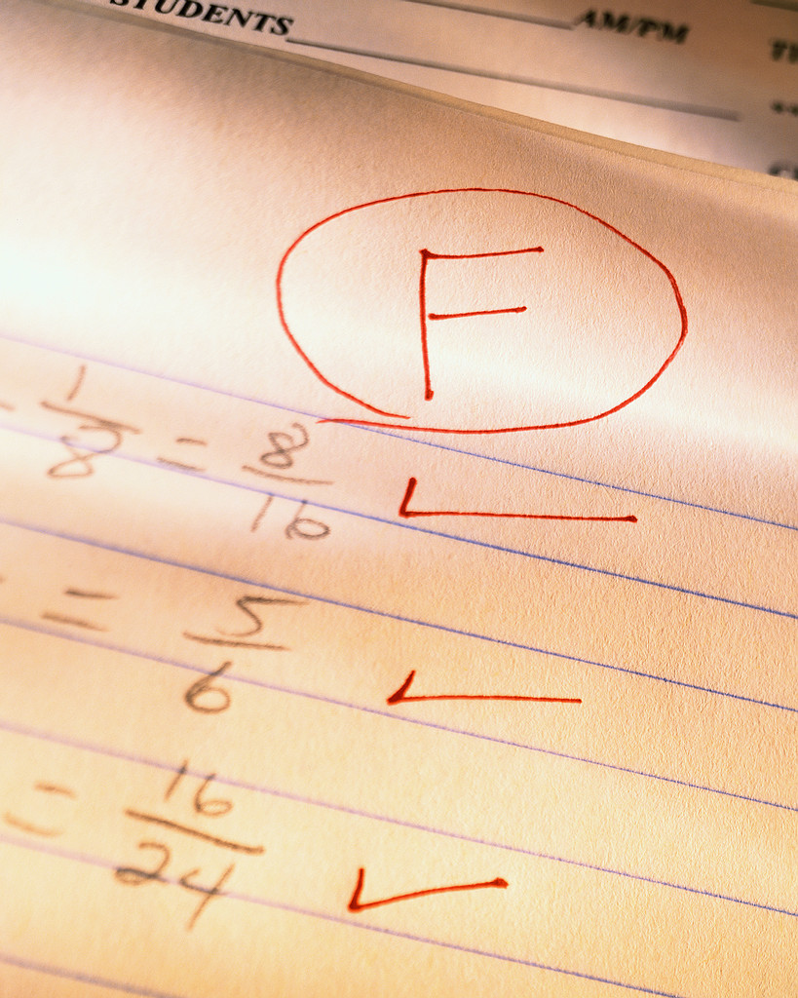
The Worst

Which website scored the lowest? What was the score?

What are the reasons/characteristics why it scored the lowest?

How would you improve this website?

Are there any interesting facts from this website?


The Best

Which website scored the highest? What was the score?

What are the reasons/characteristics why it scored the highest?

What did you like best about this website?

Are there any interesting facts from this website?

